**Screenshots for Automated Testing (All applications)**

**1. Pinch in- Pinch out:**

**(a) Pinch out:**

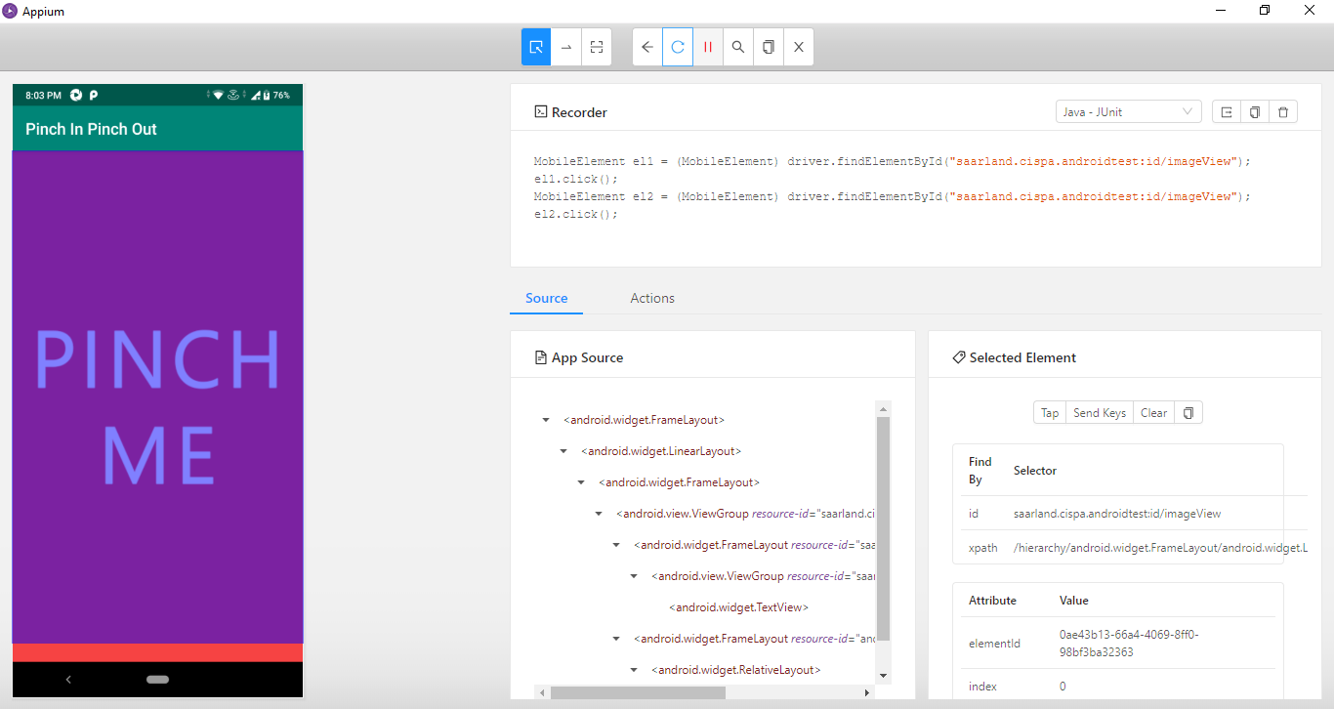

**(b) Pinch in:**

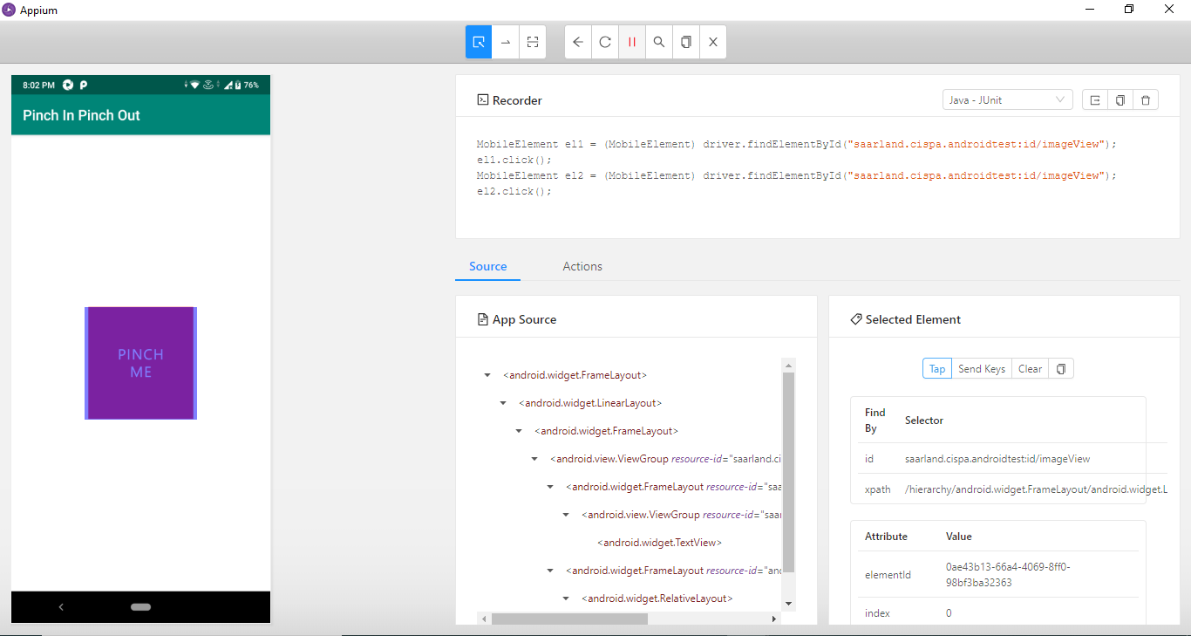

**2. Semi Transparent View:**

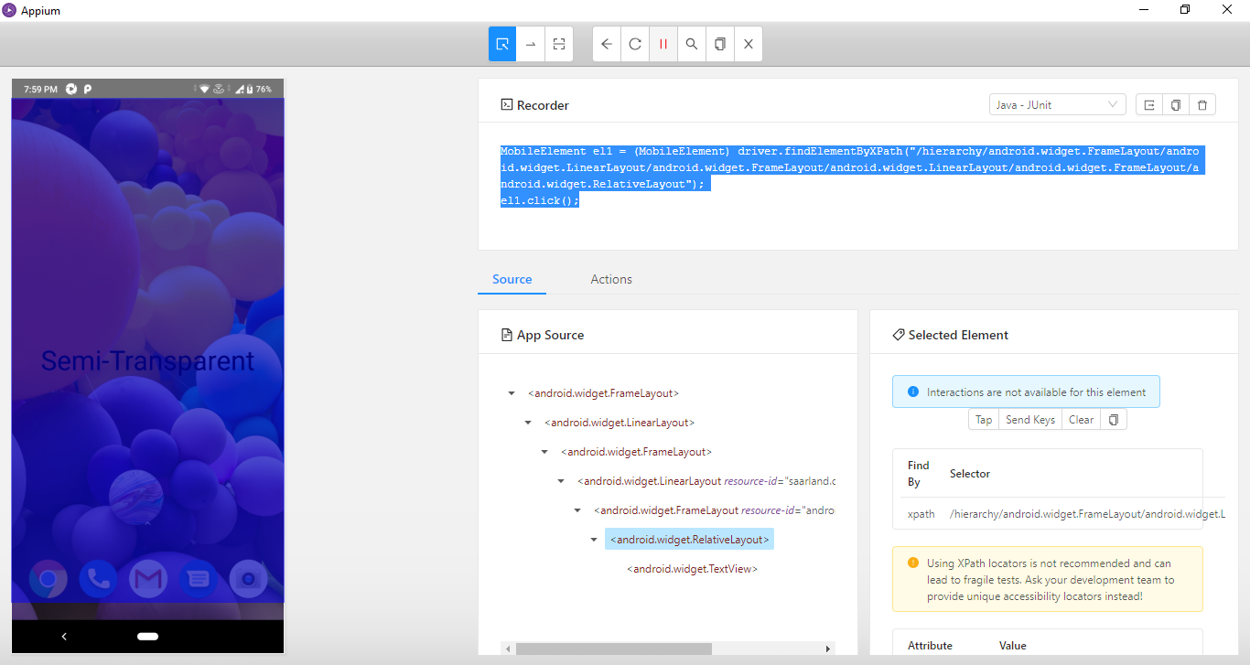

**3. Surface View:**

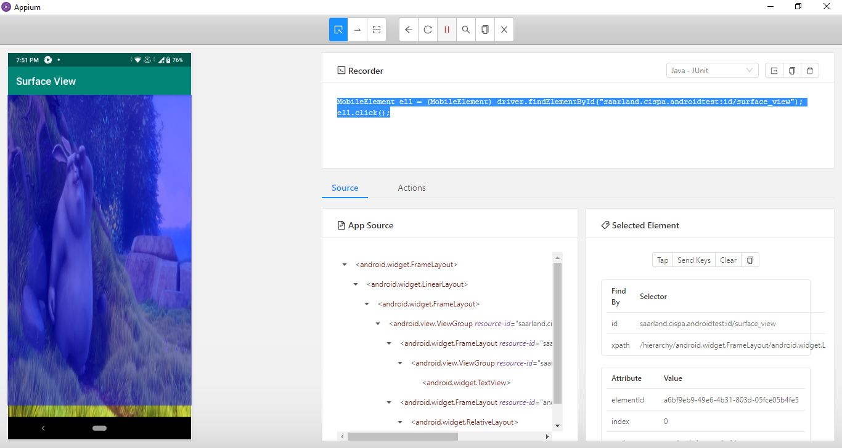

**4. Landscape Mode:**

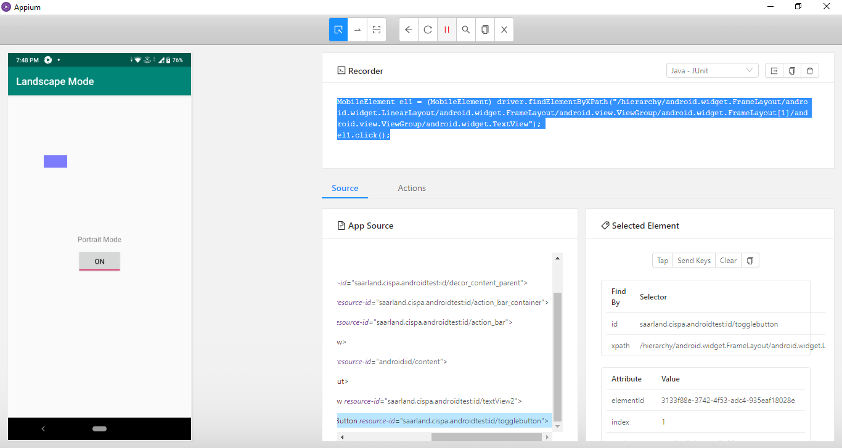

**5. Picture-in-Picture (PiP) Mode:**

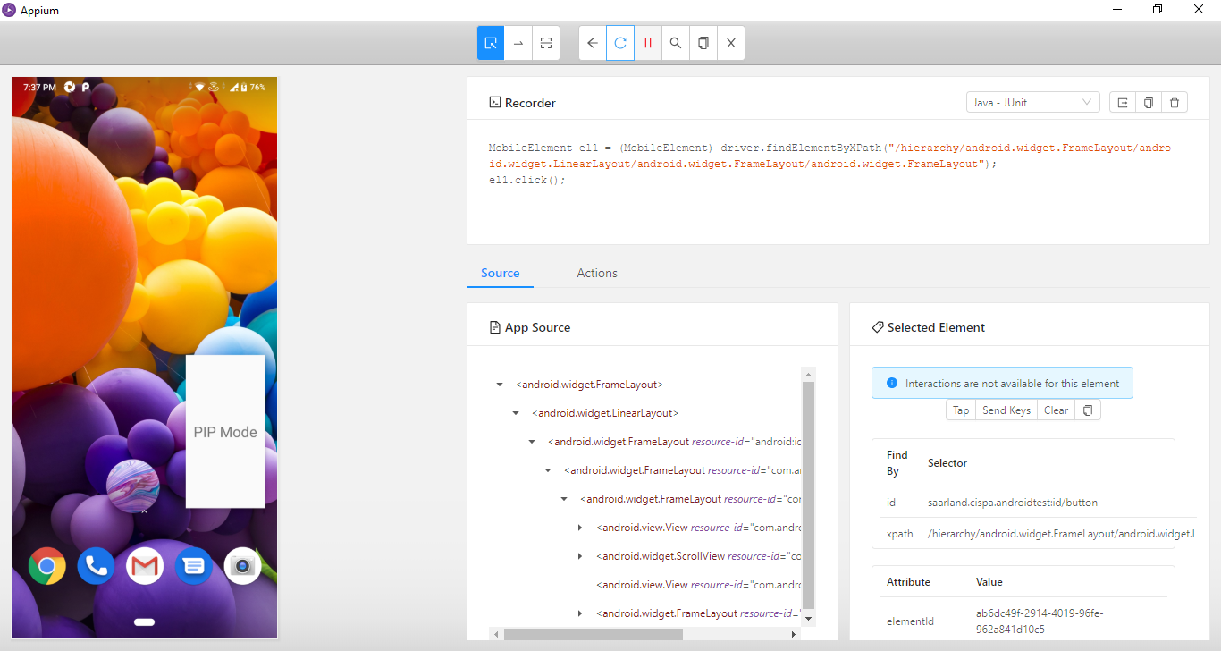

**6. Fullscreen Activity:**

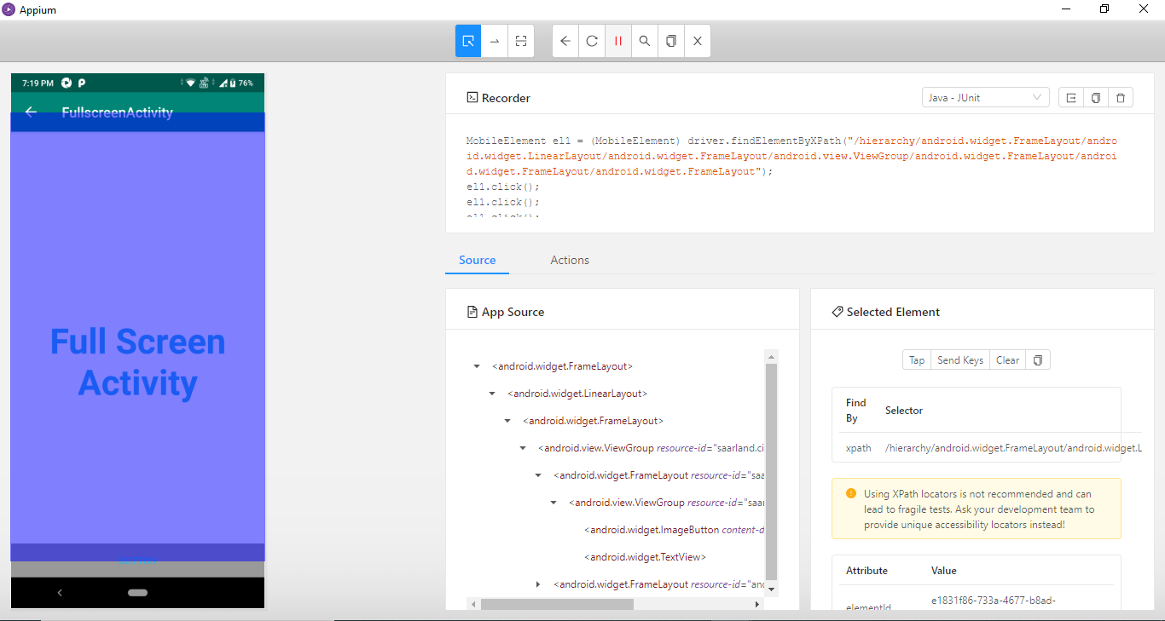

**7. WebView:**

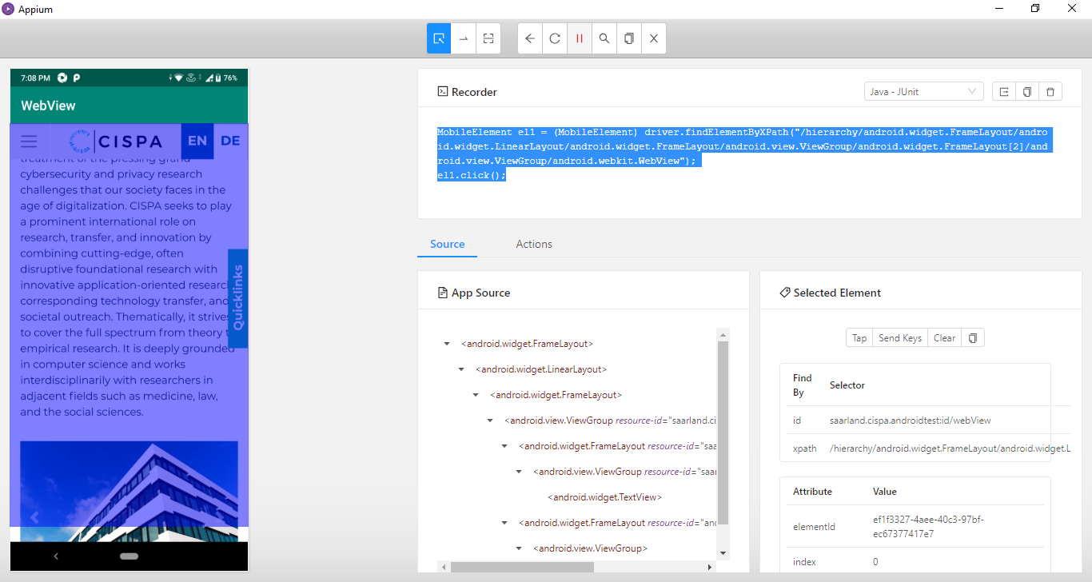

**8. Drag & Drop:**

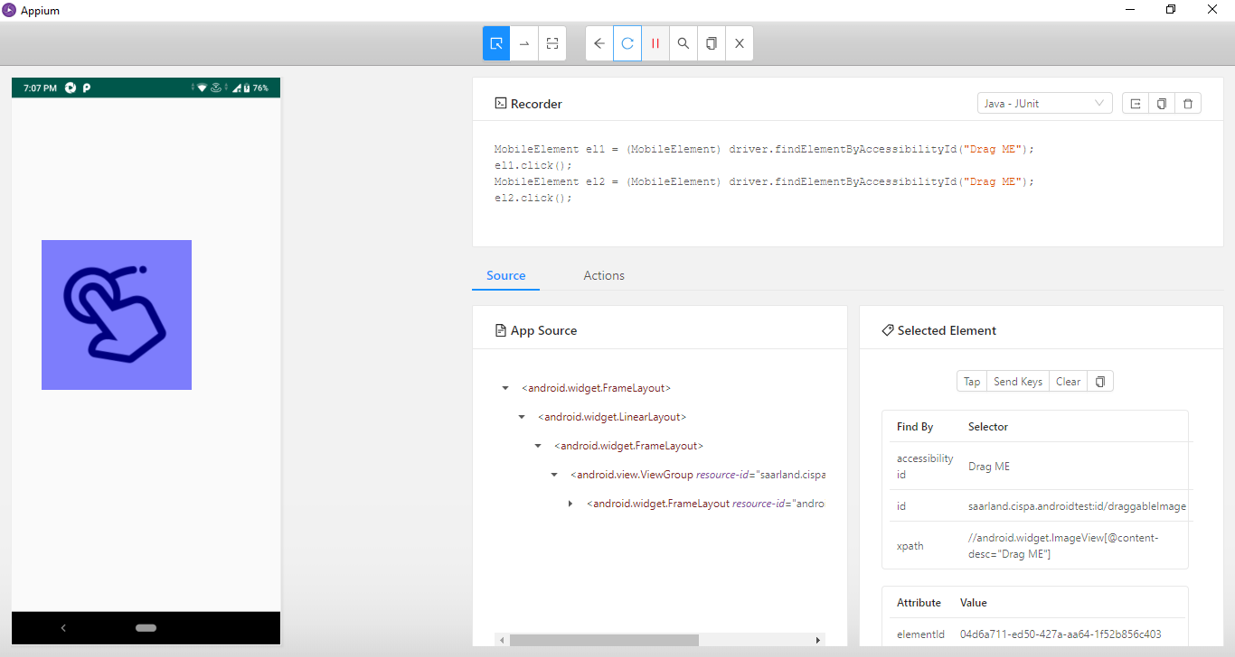

**9. Keyboard on_Load:**

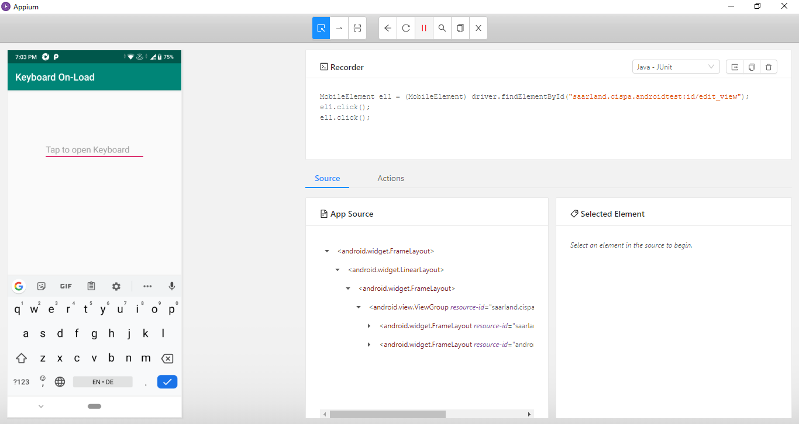

**10. Keyboard on_Focus:**

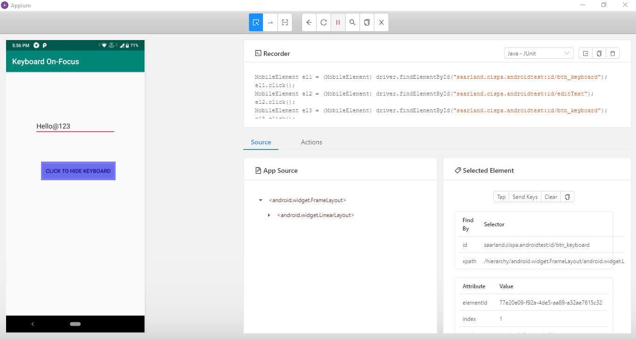

**11. Seamless Rotation:**

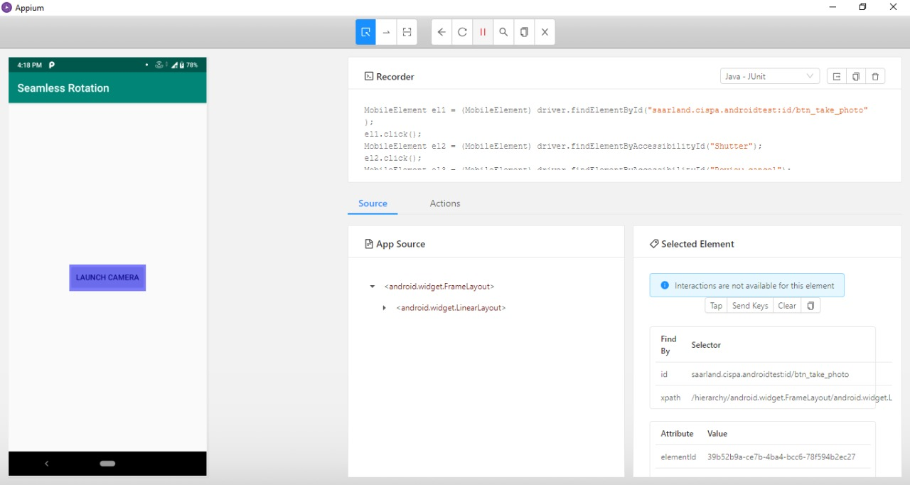

**12. Android Bubble:**

